Machine Learning,DL, Data Science
Machine Learning (ML) is a field of artificial intelligence that enables computers to learn and improve from experience without being explicitly programmed. It involves developing algorithms that can analyze data and make predictions or decisions.
Deep Learning (DL) is a specialized subset of ML that uses artificial neural networks with multiple hidden layers to learn and make decisions from complex, unstructured data like images, text, and audio. The main difference between ML and DL is the level of abstraction - DL can automatically extract high-level features from raw data, while traditional ML requires more manual feature engineering.
Data Science is an interdisciplinary field that combines statistics, mathematics, programming, and domain expertise to extract insights and knowledge from data. It encompasses both ML and DL techniques. Artificial Intelligence (AI) is the broader concept of machines being able to carry out tasks in an intelligent manner, which includes ML and DL as subfields.
ML problems can be categorized into supervised learning (predicting outputs from labeled data), unsupervised learning (finding patterns in unlabeled data), and reinforcement learning (learning through trial-and-error interactions).
DL is particularly well-suited for tackling complex, unstructured data problems like image recognition, natural language processing, and speech recognition. The types of datasets used in ML and DL can include structured data (e.g. tabular), unstructured data (e.g. text, images, audio), and time-series data. The size and quality of the dataset are critical factors for model performance.
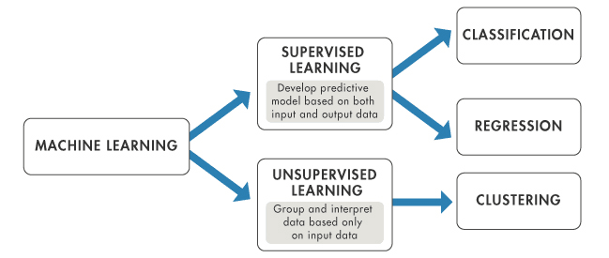
Supervised Learning:
Supervised machine learning is a type of machine learning that learns the relationship between input and output. The inputs are known as features or ‘X variables’ and output is generally referred to as the target or ‘y variable’.
The type of data which contains both the features and the target is known as labeled data.

Goals
The objective of supervised learning is to forecast results for new data based on a model that has been learned from a labeled training dataset.

There are two types of supervised learning algorithms:
- Classification
- Regression

Classification: Categorical outputs refer to the type of output variable that can take on one of a limited, fixed number of possible values, each representing a different category or class. These outputs are discrete and distinct from each other, meaning there are clear boundaries between the categories.( supervised machine learning where algorithms learn from the data to predict an outcome or event in the future.)
• Binary Classification (Two Categories):
- Email Classification: Categories could be "spam" or "not spam."
- Medical Test Result: Categories could be "positive" or "negative."
• Multiclass Classification (More Than Two Categories):
- Animal Type Identification: Categories could be "cat," "dog," "bird," etc.
- Customer Satisfaction: Categories could be "very satisfied," "satisfied," "neutral," "dissatisfied," or "very dissatisfied."

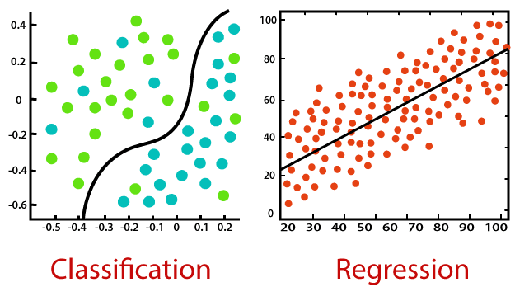
**By understanding the nature of the target variable (continuous for regression, categorical for classification), you can determine the type of machine learning task and appropriate model to use.**
for classification tasks. Some of them are:
- Logistic Regression
- Decision Tree Classifier
- K Nearest Neighbor Classifier
- Random Forest Classifier
- Neural Networks

Regression
Regression is a type of supervised machine learning where algorithms learn from the data to predict continuous values such as sales, salary, weight, or temperature. For example:
A dataset containing features of the house such as lot size, number of bedrooms, number of baths, neighborhood, etc. and the price of the house, a Regression algorithm can be trained to learn the relationship between the features and the price of the house.
Many machine learning algorithms can be used for regression tasks. Some of them are:
- Linear Regression
- Decision Tree Regressor
- K Nearest Neighbor Regressor
- Random Forest Regressor
- Neural Networks

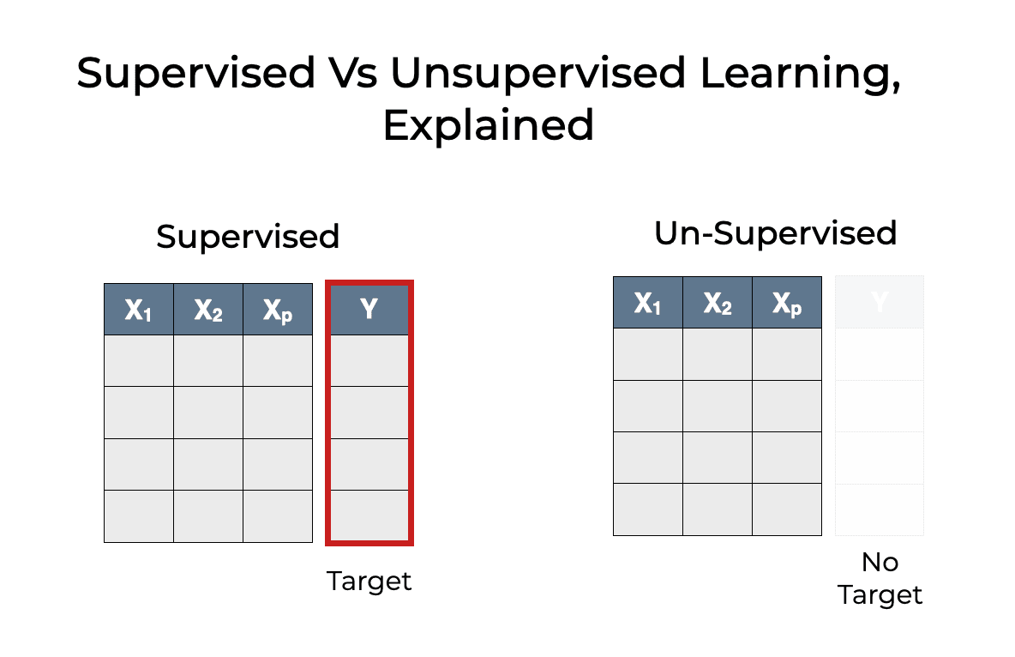
Supervised Algorithms:

Linear Regression: used to learn to predict continuous value (dependent variable) based on the features (independent variable) in the training dataset.

line of best fit


PROS | CONS
Simple, easy to understand and interpret | Easy to overfit
Performs exceptionally well for linearly separable data | Assumes linearity between features and target variable.

For terminology(for my reference):
• Underfitting:
- The model is too simple to capture the underlying pattern of the data. It results in high error on both the training and new data.
- Diagram shows a straight line far from most data points.
• Good Fit:
- The model captures the underlying pattern of the data well. It performs well on both the training data and new, unseen data.
- Diagram shows a curve that follows the general trend of the data points.
• Overfitting:
- The model is too complex and captures the noise and details of the training data. It performs well on the training data but poorly on new data.
- Diagram shows a highly wavy line that passes through all training points, including noise.

Logistic Regression
Logistic Regression is a special case of Linear Regression where target variable (y) is discrete / categorical such as 1 or 0, True or False, Yes or No, Default or No Default. A log of the odds is used as the dependent variable. Using a logit function(sigmoid function), logistic regression makes predictions about the probability that a binary event will occur.

Logistic Function Formula (Logistic Regression):
- 1
- P(y=1∣x)= --------------------------------------
- −(β0​+β1​x1​+β2​x2​+⋯+βn​xn​)
- 1+e

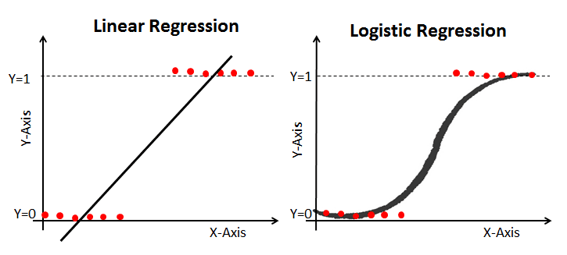
Sure, here's a table summarizing the pros and cons of logistic regression:

| **Pros** | **Cons** |
|-------------------------------------------------------|---------------------------------------------------------|
| Simple and interpretable | Assumes linearity in the log-odds |
| Computationally efficient | Limited to linear decision boundaries |
| Provides probabilistic outputs | Primarily binary classification |
| No assumptions about data distribution | Sensitive to outliers |
| Supports regularization (L1 and L2) | Requires careful data preparation |
| Minimal feature scaling needed | Struggles with imbalanced datasets |

Decision Trees
A decision tree is a supervised learning algorithm used for both classification and regression tasks. It works by splitting the data into subsets based on the value of input features, creating a tree structure where each node represents a feature, each branch represents a decision rule, and each leaf node represents an outcome.

Working Principle
The decision tree algorithm operates recursively:
- Select the Best Feature: Choose the best feature to split the data at the root node based on a criterion like Gini impurity, entropy (information gain), or mean squared error (for regression).
- Split the Data: Split the data into subsets where each subset contains data with the same feature value.
- Repeat: Recursively repeat the process for each child node until one of the stopping conditions is met (e.g., maximum depth, minimum samples per leaf, or no further improvement in splitting criteria).
Splitting criteria:
Entropy , Mean squared error, Information Gain
Sure, here is a table summarizing the pros and cons of decision trees:

| **Pros** | **Cons** |
|-----------------------------------------------------------------|------------------------------------------------------------------|
| Simple to understand and interpret | Prone to overfitting |
| Can handle both numerical and categorical data | Can create biased trees if some classes dominate|
| Requires little data preparation | Sensitive to small changes in the data |
| Capable of capturing non-linear relationships | Can be less accurate than other models |
| Provides a clear indication of feature importance | High computational cost for large trees |

This table captures the key advantages and disadvantages of using decision trees for machine learning tasks.

decision tree algorithms:
- ID3 (Iterative Dichotomiser 3)-uses information gain, Handles categorical data but not continuous variables directly.
- C4.5-Handles both categorical and continuous data. Uses Information Gain Ratio to overcome the bias towards attributes with many values. Handles missing values effectively.
- CART (Classification and Regression Trees)
- CHAID (Chi-square Automatic Interaction Detection)- Based on the chi-square statistical test of independence.
- Random Forest
- Gradient Boosted Trees (GBT)

K Nearest Neighbors:
It is a lazy algorithm. It will not learn from training data. It memorizes the training data.It uses Euclidian distance. For every data point, it find out the Euclidian distance. Based on no of k values it selects that many no of shortest distances.
i)Small k-low bias,high variance , overfitting
ii)Large k- high bias, low variance, underfitting
We return the average of the K nearest neighbors labels as prediction. When we add a new data point, the group of that instance will depend on which group the new point is closer to.


PROS | CONS
Makes no assumption about the data | Takes long time for training
Intuitive and simple | KNN works well with a small number of features but as the numbers of features grow it struggles to predict accurately.

Random Forest:

Random Forest is another example of an algorithm that is built on trees, just like Decision Trees. In contrast to Decision Tree, which only consists of a single tree, Random Forest employs a number of Decision Trees in order to make judgments, creating what is essentially a forest of trees.

It does this by combining a number of different models in order to produce predictions, and it may be used for both classification and regression.



PROS | CONS
Random Forests can handle non-linear relationships in the data easily. | Difficult to interpret because of multiple trees.
Random Forests implicitly perform feature selection | Random Forests are computationally expensive for large datasets.

SVM:
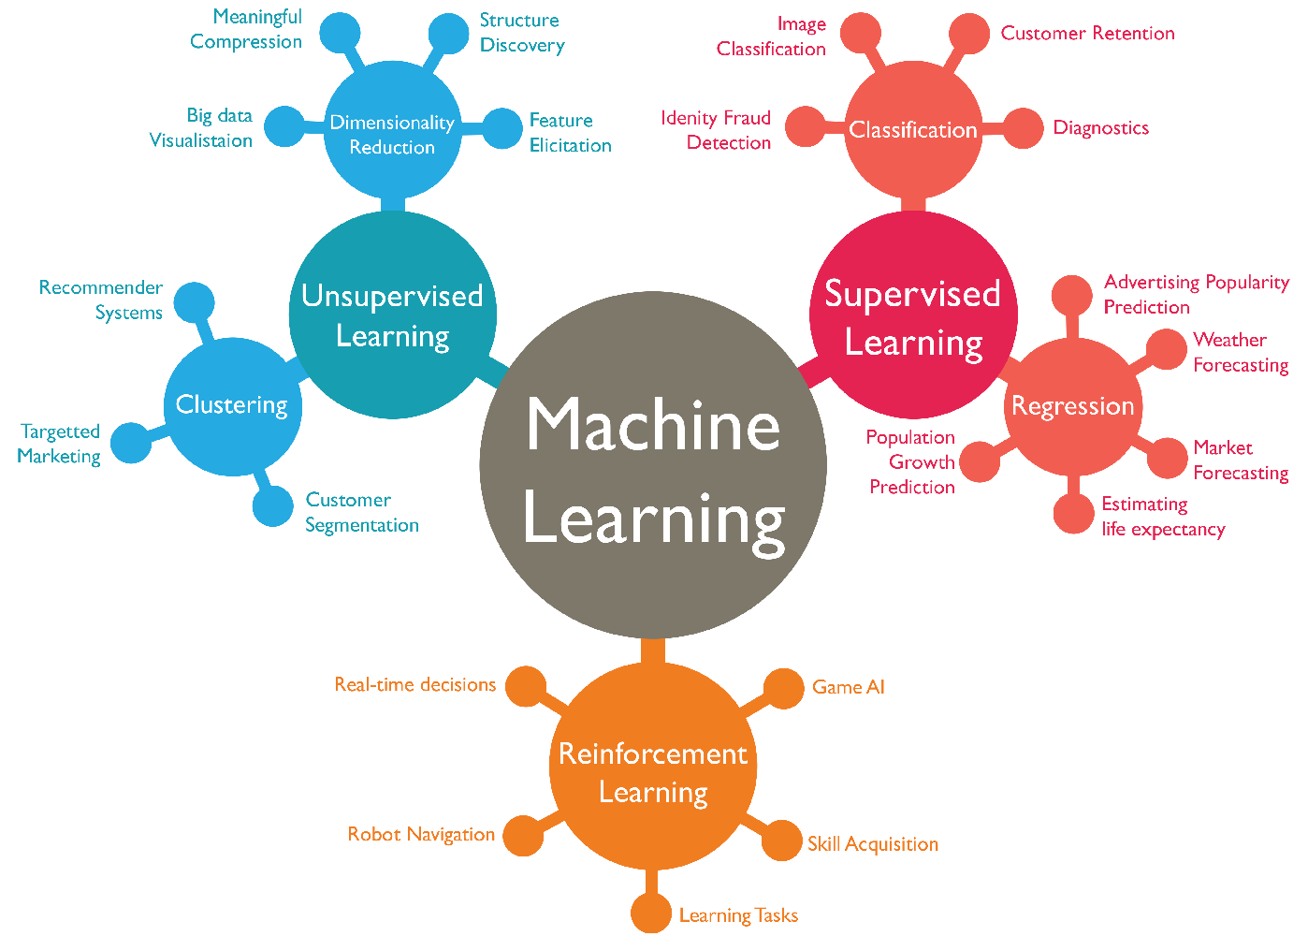
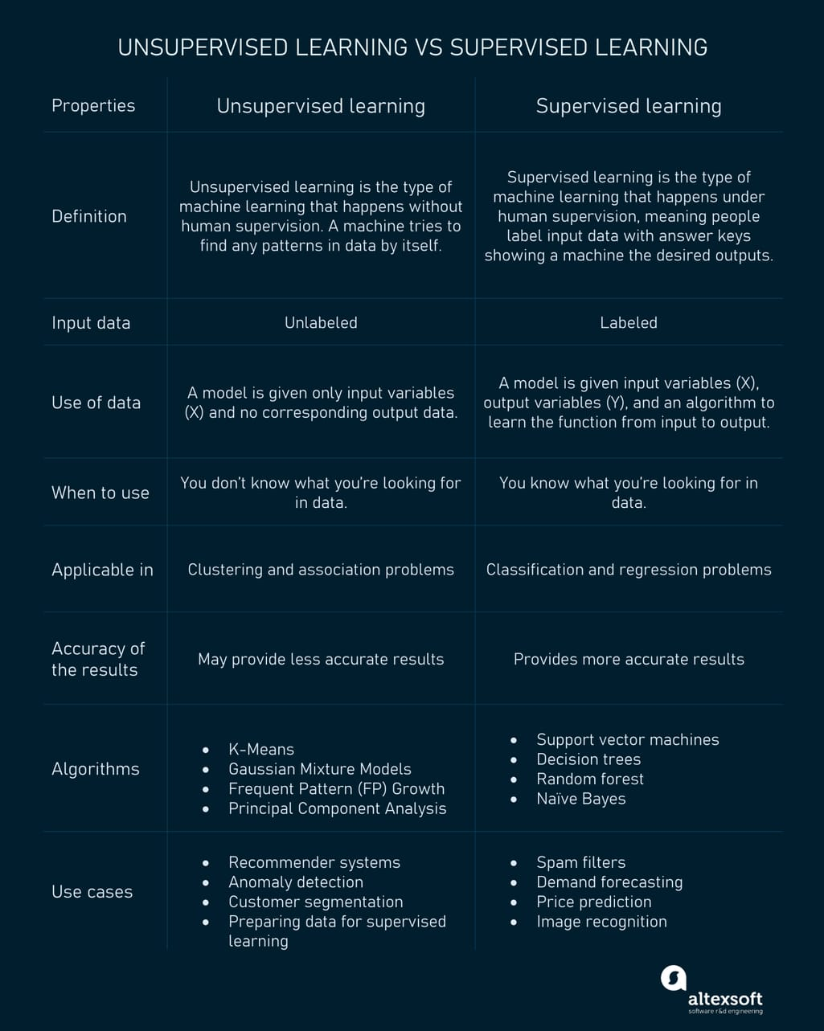

Unsupervised Learning:
1.Clusterin
Clustering
Clustering is an unsupervised learning technique that groups similar data points together, allowing the identification of patterns and structures within a dataset without relying on pre-defined labels or categories.
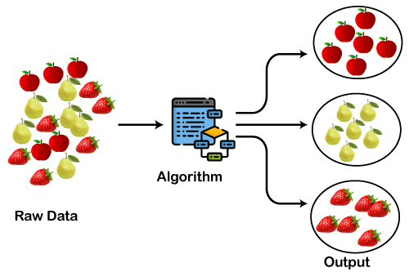
Dimensionality Reduction
[open link]

Dimensionality reduction is a technique in unsupervised learning that aims to decrease the number of variables in a dataset while retaining as much of the important information as possible. Unlike other unsupervised methods, dimensionality reduction seeks to identify the most essential features that capture the underlying structure of the data.

Clustering:

1.K-means Clustering
2. Hierarchial Clustering

1.K Means Clustering:
partitions data into K distinct clusters based on the similarity of data points, by iteratively minimizing the sum of squared distances between data points and their assigned cluster centroids

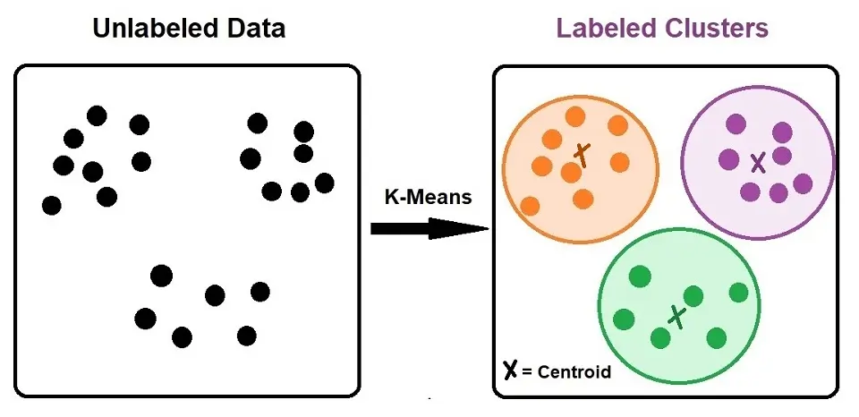

Principal Component Analysis (PCA)
[open link]

Principal Component Analysis (PCA) is a dimensionality reduction technique that identifies the main directions of variance in a dataset and projects the data onto a lower-dimensional subspace defined by these principal components.

